Test Case: tc005_SPX_Dev5_Crear_Requisicion_Spot_Con_FAD_Tipo_Cobro_Project
Step 1 - Enter username and password and click to button Enter: Credentials Entered
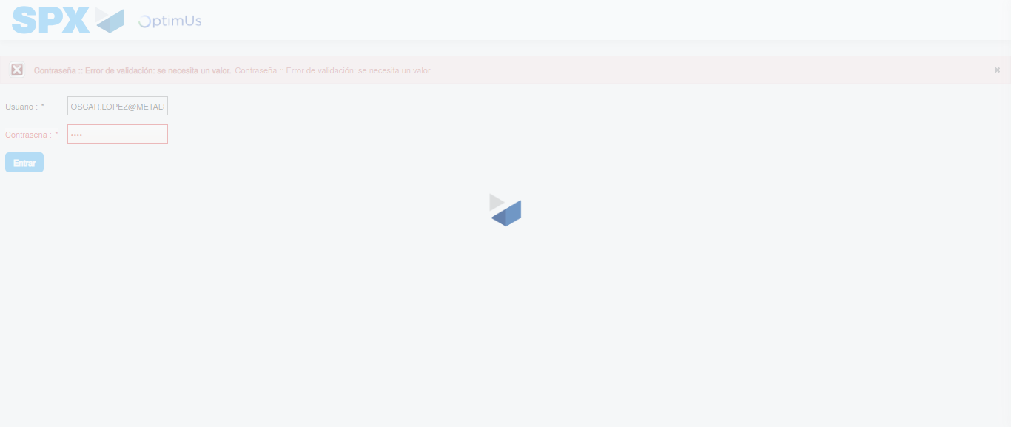Image file-name: QC_Testing-tc005_SPX_Dev5_Crear_Requisicion_Spot_Con_FAD_Tipo_Cobro_Project-1784572751449

Step 2 - Select to UEN and Access to Spot Buy Requisitions : UEN Correctly selected and Correct access
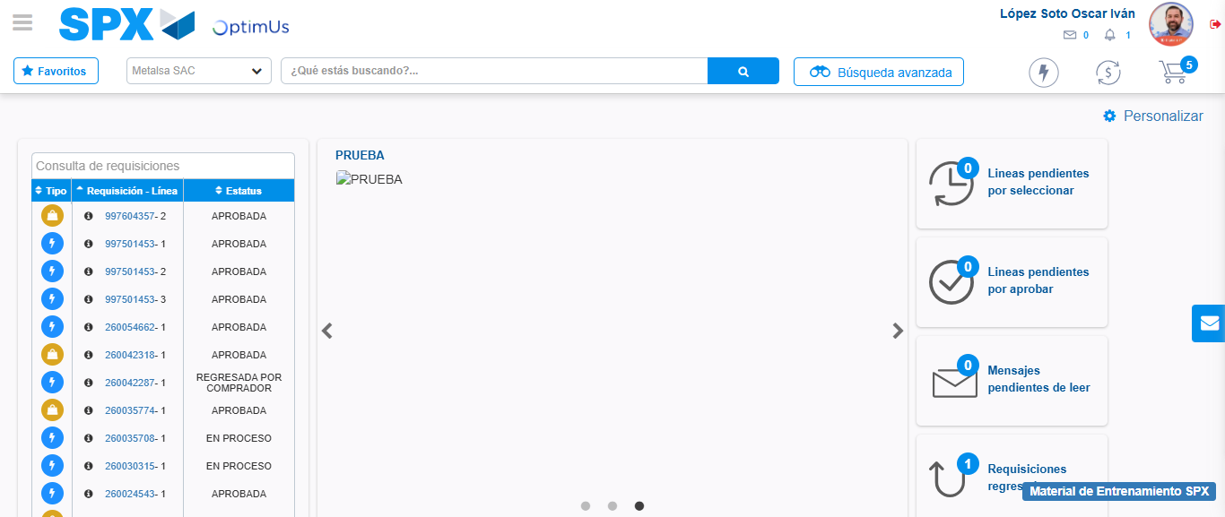Image file-name: QC_Testing-tc005_SPX_Dev5_Crear_Requisicion_Spot_Con_FAD_Tipo_Cobro_Project-1784572828322

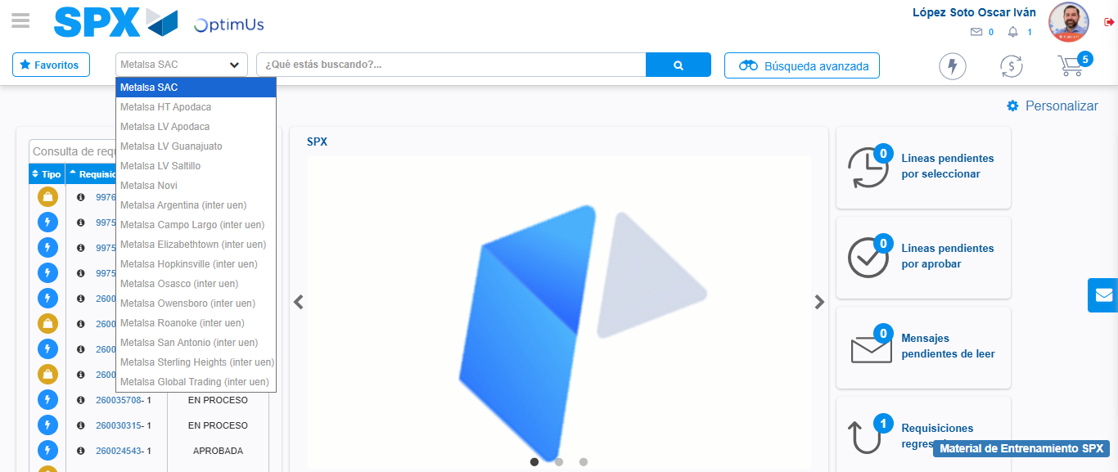Image file-name: QC_Testing-tc005_SPX_Dev5_Crear_Requisicion_Spot_Con_FAD_Tipo_Cobro_Project-1784572831178

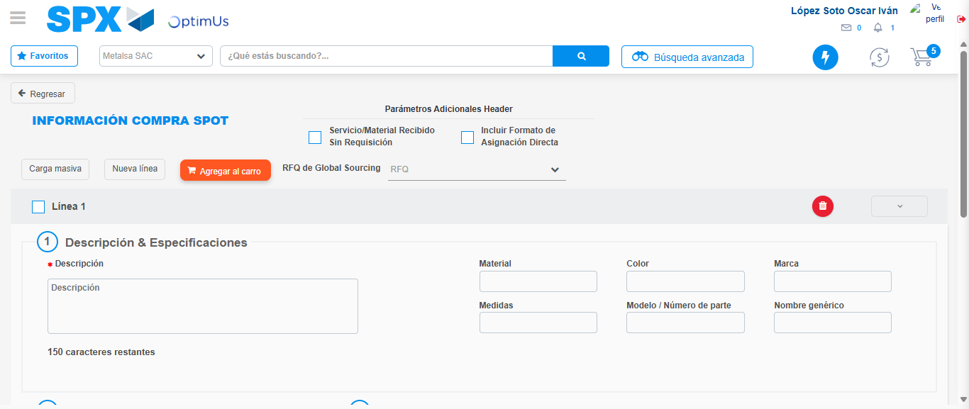Image file-name: QC_Testing-tc005_SPX_Dev5_Crear_Requisicion_Spot_Con_FAD_Tipo_Cobro_Project-1784572844001

Step 3 - Add FAD to Requisition: FAD Successfully Added
Image file-name: QC_Testing-tc005_SPX_Dev5_Crear_Requisicion_Spot_Con_FAD_Tipo_Cobro_Project-1784572844286

Image file-name: QC_Testing-tc005_SPX_Dev5_Crear_Requisicion_Spot_Con_FAD_Tipo_Cobro_Project-1784572844519

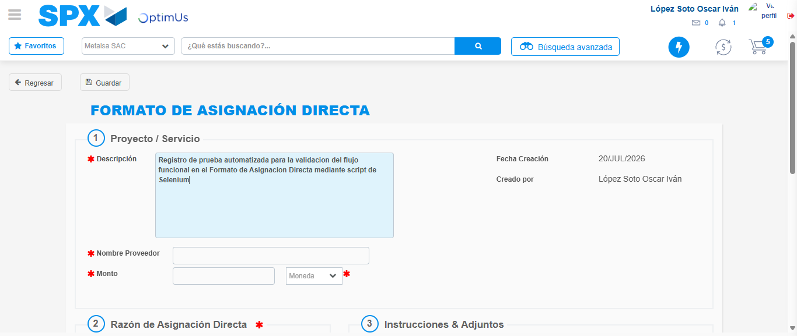Image file-name: QC_Testing-tc005_SPX_Dev5_Crear_Requisicion_Spot_Con_FAD_Tipo_Cobro_Project-1784572847673

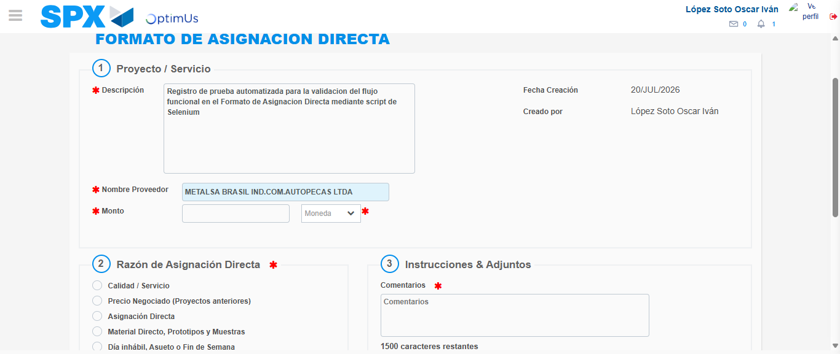Image file-name: QC_Testing-tc005_SPX_Dev5_Crear_Requisicion_Spot_Con_FAD_Tipo_Cobro_Project-1784572854354

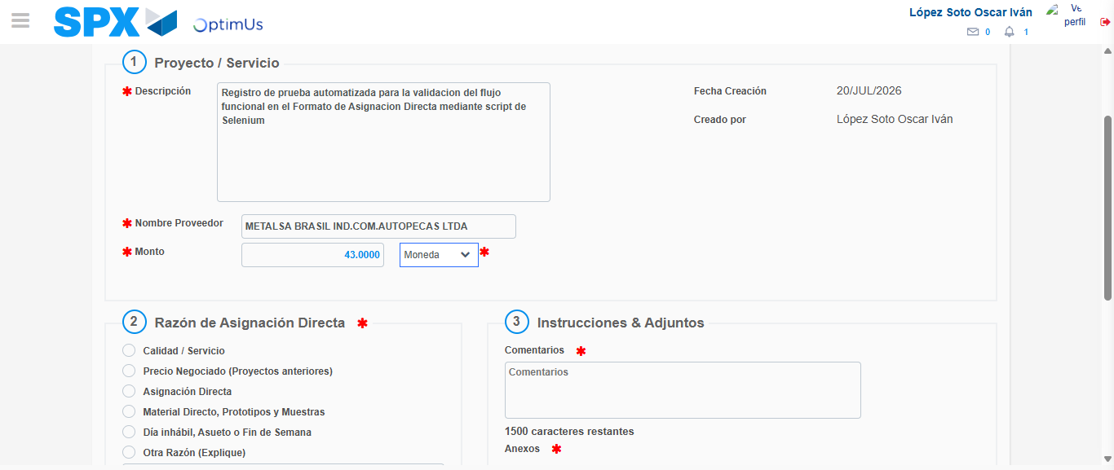Image file-name: QC_Testing-tc005_SPX_Dev5_Crear_Requisicion_Spot_Con_FAD_Tipo_Cobro_Project-1784572854846

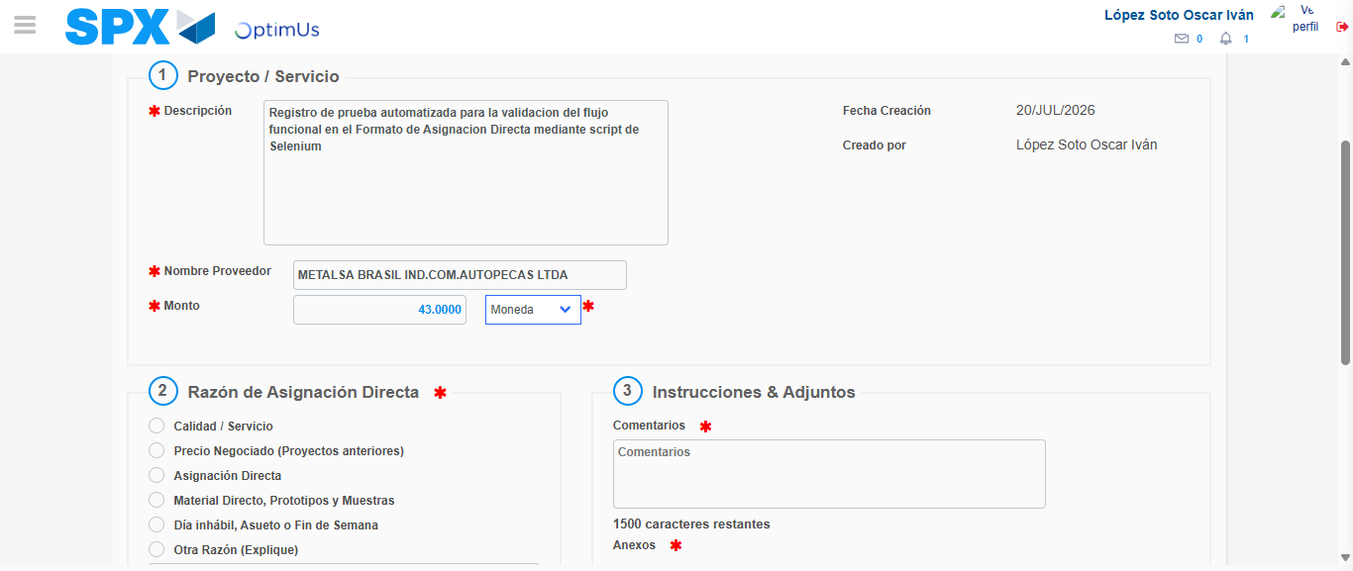Image file-name: QC_Testing-tc005_SPX_Dev5_Crear_Requisicion_Spot_Con_FAD_Tipo_Cobro_Project-1784572855074

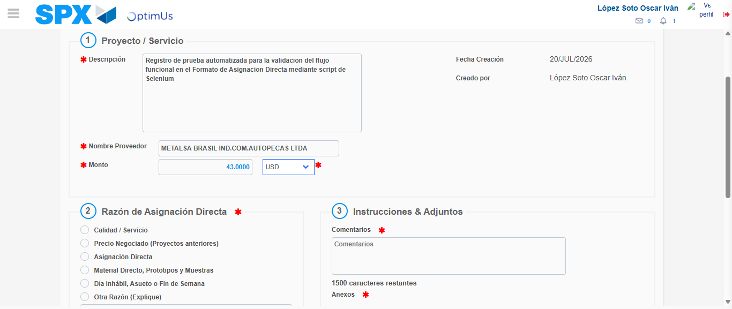Image file-name: QC_Testing-tc005_SPX_Dev5_Crear_Requisicion_Spot_Con_FAD_Tipo_Cobro_Project-1784572855536

Image file-name: QC_Testing-tc005_SPX_Dev5_Crear_Requisicion_Spot_Con_FAD_Tipo_Cobro_Project-1784572855757

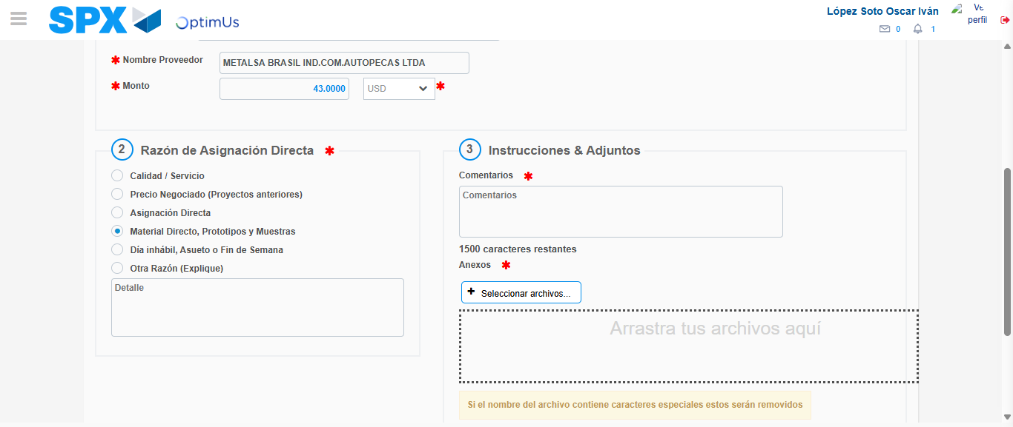Image file-name: QC_Testing-tc005_SPX_Dev5_Crear_Requisicion_Spot_Con_FAD_Tipo_Cobro_Project-1784572856725

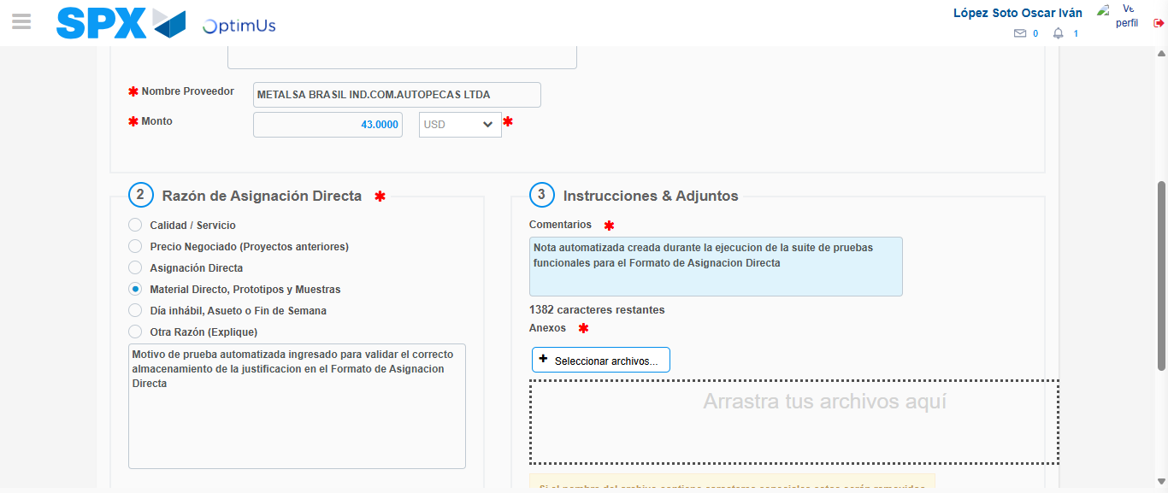Image file-name: QC_Testing-tc005_SPX_Dev5_Crear_Requisicion_Spot_Con_FAD_Tipo_Cobro_Project-1784572868106

Image file-name: QC_Testing-tc005_SPX_Dev5_Crear_Requisicion_Spot_Con_FAD_Tipo_Cobro_Project-1784572868987

Step 4 - Data Capture Spot Buy Requisition: Data captured correctly
Image file-name: QC_Testing-tc005_SPX_Dev5_Crear_Requisicion_Spot_Con_FAD_Tipo_Cobro_Project-1784572844286

Image file-name: QC_Testing-tc005_SPX_Dev5_Crear_Requisicion_Spot_Con_FAD_Tipo_Cobro_Project-1784572844519

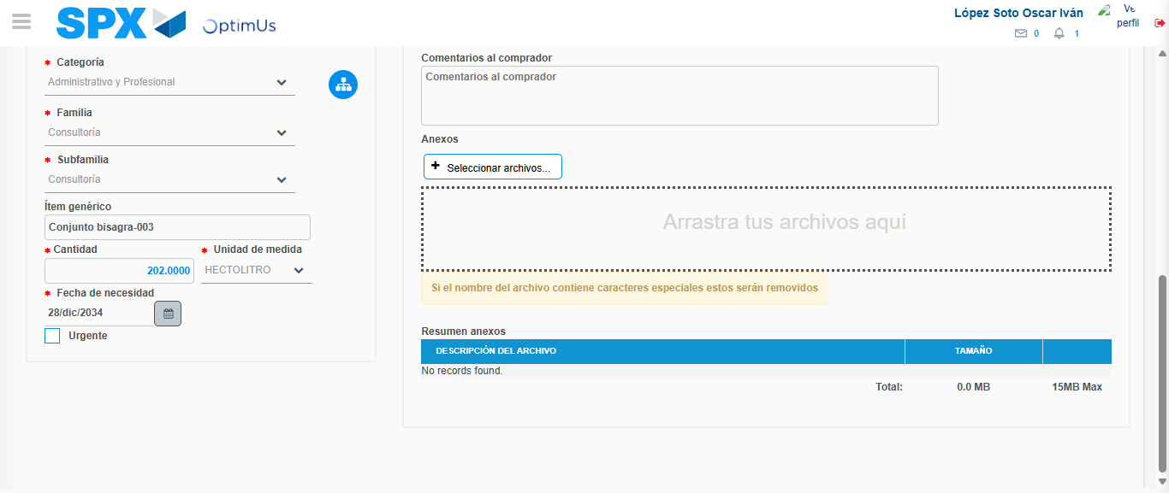Image file-name: QC_Testing-tc005_SPX_Dev5_Crear_Requisicion_Spot_Con_FAD_Tipo_Cobro_Project-1784572887356

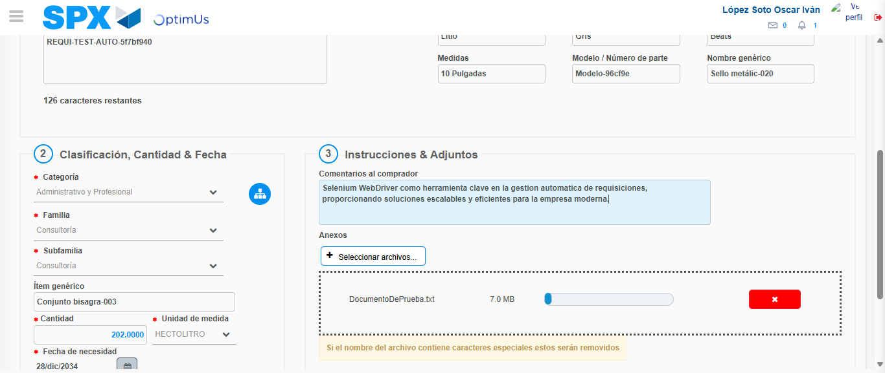Image file-name: QC_Testing-tc005_SPX_Dev5_Crear_Requisicion_Spot_Con_FAD_Tipo_Cobro_Project-1784572888332

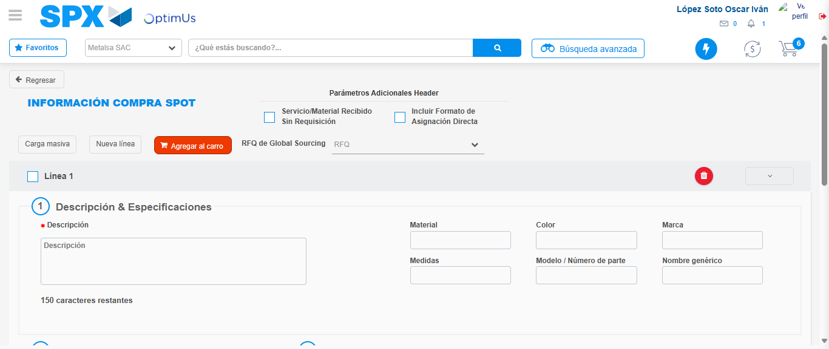Image file-name: QC_Testing-tc005_SPX_Dev5_Crear_Requisicion_Spot_Con_FAD_Tipo_Cobro_Project-1784572895548

Step 8 - Return to Main Page SPX : Return to Main Page SPX
Image file-name: QC_Testing-tc005_SPX_Dev5_Crear_Requisicion_Spot_Con_FAD_Tipo_Cobro_Project-1784572828322

Image file-name: QC_Testing-tc005_SPX_Dev5_Crear_Requisicion_Spot_Con_FAD_Tipo_Cobro_Project-1784572831178

Image file-name: QC_Testing-tc005_SPX_Dev5_Crear_Requisicion_Spot_Con_FAD_Tipo_Cobro_Project-1784572844001

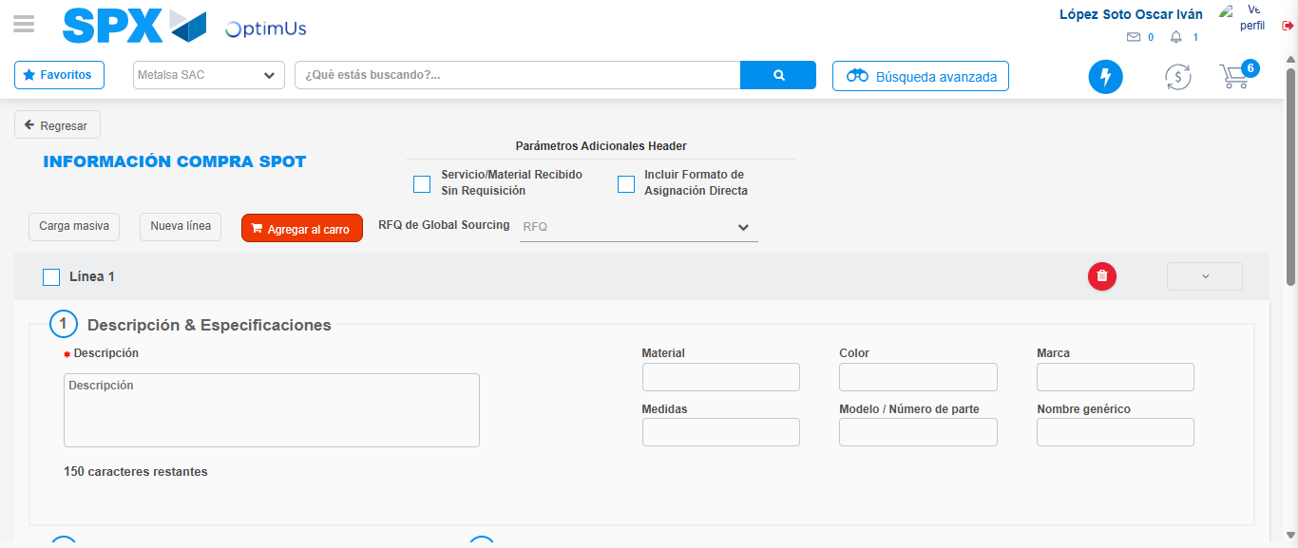Image file-name: QC_Testing-tc005_SPX_Dev5_Crear_Requisicion_Spot_Con_FAD_Tipo_Cobro_Project-1784572897813

Image file-name: QC_Testing-tc005_SPX_Dev5_Crear_Requisicion_Spot_Con_FAD_Tipo_Cobro_Project-1784572897997

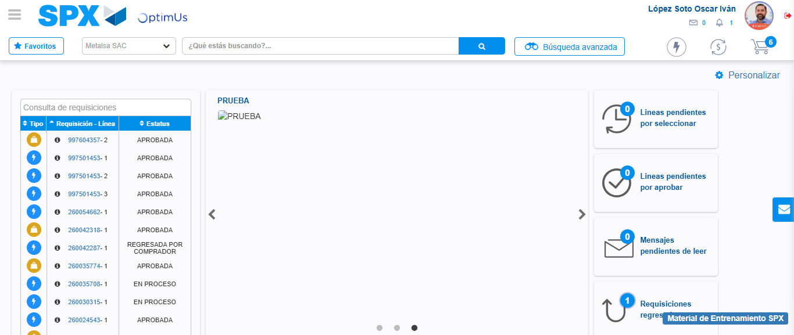Image file-name: QC_Testing-tc005_SPX_Dev5_Crear_Requisicion_Spot_Con_FAD_Tipo_Cobro_Project-1784572919237

Step 9 - Log Out : Log Out SPX
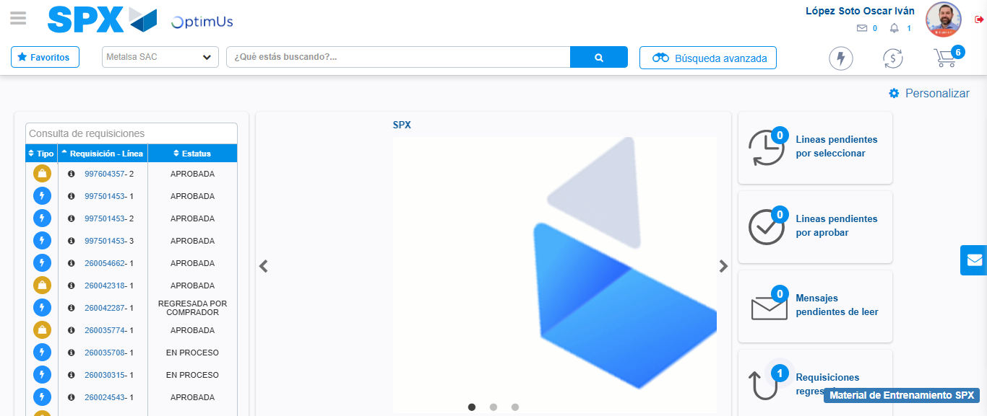Image file-name: QC_Testing-tc005_SPX_Dev5_Crear_Requisicion_Spot_Con_FAD_Tipo_Cobro_Project-1784572919609

